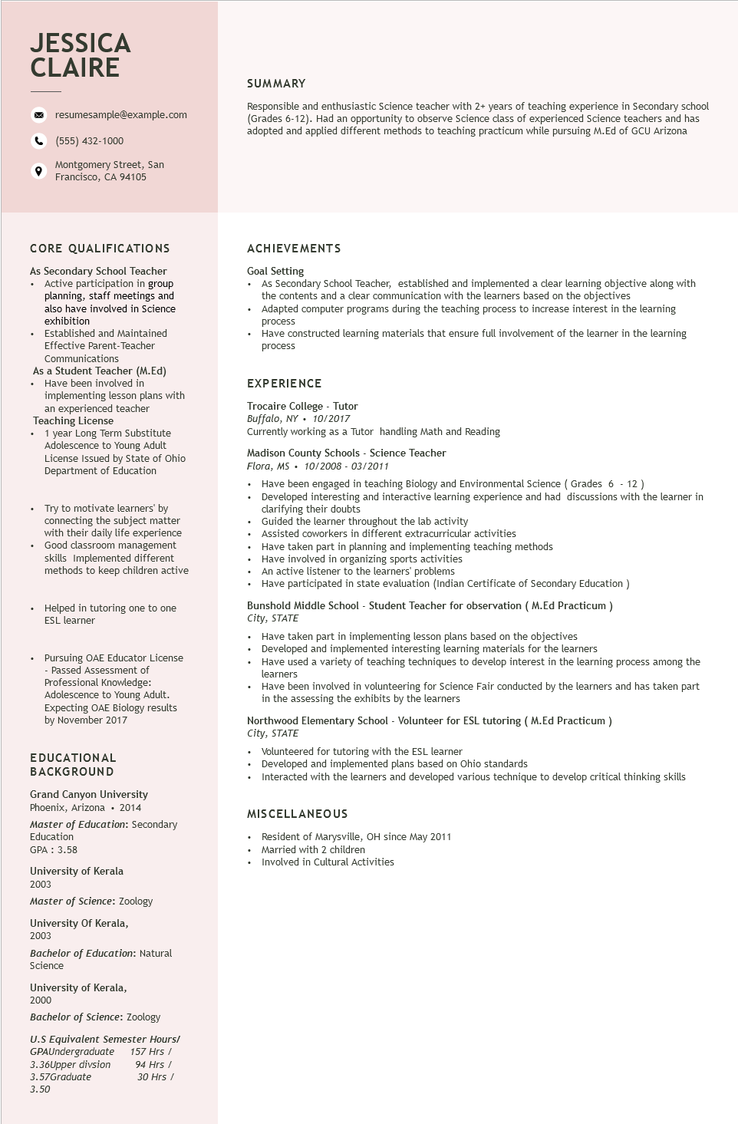
JESSICA CLAIRE
resumesample@example.com
(555) 432-1000
Montgomery Street, San Francisco, CA 94105
SUMMARY
Responsible and enthusiastic Science teacher with 2+ years of teaching experience in Secondary school (Grades 6-12). Had an opportunity to observe Science class of experienced Science teachers and has adopted and applied different methods to teaching practicum while pursuing M.Ed of GCU Arizona
CORE QUALIFICATIONS
As Secondary School Teacher • Active participation in group planning, staff meetings and also have involved in Science exhibition
+
Established and Maintained Effective Parent-Teacher Communications
As a Student Teacher (M.Ed)
• Have been involved in
implementing lesson plans with
an experienced teacher
Teaching License
⚫ 1 year Long Term Substitute Adolescence to Young Adult License Issued by State of Ohio Department of Education
Try to motivate learners' by connecting the subject matter with their daily life experience • Good classroom management skills Implemented different methods to keep children active
Helped in tutoring one to one ESL learner
Pursuing OAE Educator License -Passed Assessment of Professional Knowledge: Adolescence to Young Adult.
Expecting OAE Biology results by November 2017
EDUCATIONAL
BACKGROUND
Grand Canyon University
Phoenix, Arizona⚫ 2014
Master of Education: Secondary
Education
GPA: 3.58
University of Kerala
2003
Master of Science: Zoology
University of Kerala, 2003
Bachelor of Education: Natural Science
University of Kerala,
2000
Bachelor of Science: Zoology
U.S Equivalent Semester Hours/
GPAUndergraduate
3.36Upper divsion
3.57Graduate
157 Hrs /
94 Hrs /
30 Hrs /
ACHIEVEMENTS
Goal Setting
• As Secondary School Teacher, established and implemented a clear learning objective along with the contents and a clear communication with the learners based on the objectives
Adapted computer programs during the teaching process to increase interest in the learning process
• Have constructed learning materials that ensure full involvement of the learner in the learning process
EXPERIENCE
Trocaire College - Tutor
Buffalo, NY. 10/2017
Currently working as a Tutor handling Math and Reading
Madison County Schools - Science Teacher
Flora, MS. 10/2008 - 03/2011
• Have been engaged in teaching Biology and Environmental Science (Grades 6 - 12 )
•
Developed interesting and interactive learning experience and had discussions with the learner in clarifying their doubts
• Guided the learner throughout the lab activity
• Assisted coworkers in different extracurricular activities
• Have taken part in planning and implementing teaching methods
• Have involved in organizing sports activities
•
An active listener to the learners' problems
• Have participated in state evaluation (Indian Certificate of Secondary Education)
Bunshold Middle School - Student Teacher for observation (M.Ed Practicum) City, STATE
• Have taken part in implementing lesson plans based on the objectives Developed and implemented interesting learning materials for the learners
• Have used a variety of teaching techniques to develop interest in the learning process among the learners
• Have been involved in volunteering for Science Fair conducted by the learners and has taken part in the assessing the exhibits by the learners
Northwood Elementary School - Volunteer for ESL tutoring (M.Ed Practicum)
City, STATE
• Volunteered for tutoring with the ESL learner
• Developed and implemented plans based on Ohio standards
• Interacted with the learners and developed various technique to develop critical thinking skills
MISCELLANEOUS
Resident of Marysville, OH since May 2011 Married with 2 children
• Involved in Cultural Activities
3.50

